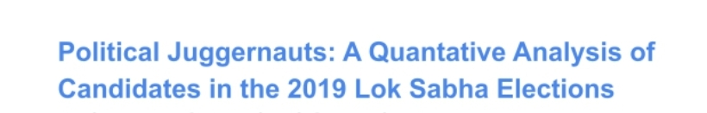 **1 INTRODUCTION**

* 1. **Overview**

The Lok Sabha is composed of representatives of people chosen by direct election on the basis of Universal Adult Suffrage. The Constitution of India allows for a maximum of 550 members in the House, with 530 members representing the States and 20 representing the Union Territories. The 17th Lok Sabha was formed by the members elected in the 2019 Indian general election. Elections, all across India, were conducted in seven phases from 11 April 2019 to 19 May 2019 by the Election Commission of India.

* 1. **Purpose**

It brings a Clarity to know what are the weak places and which type of votes supports which party and which Category votes support which Party.

1. **Problem Definition & Design Thinking**
   1. **Empathy Map**

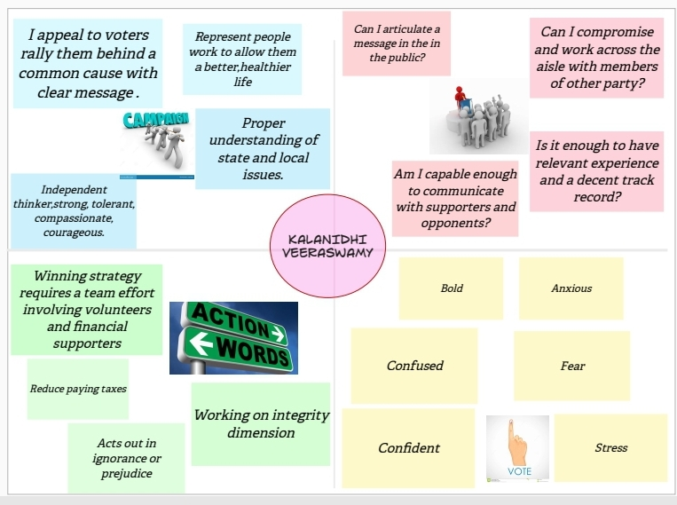

* 1. **Ideation & Brainstorming Map**

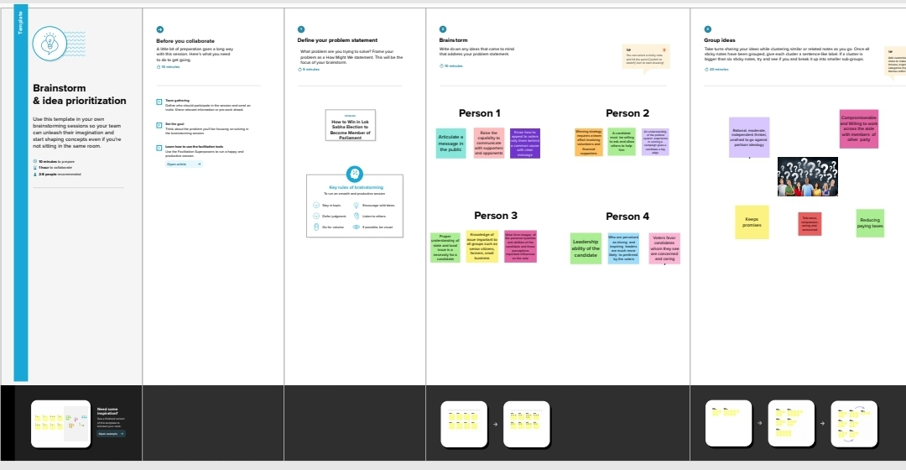

# RESULT

# ADVANTAGES & DISADVANTAGES

By conducting an analysis the Party can identify areas for improvement and take steps to enhance the Votes, and increase voter satisfaction and loyalty. Improve its Party reputation, which can lead to increased Voter loyalty.

# APPLICATIONS

The Requirement is to analyse the winners and total voters and electors and Postal Votes of Lok Sabha, and criminal Cases in Each State & Party. In which State There are more winners and which party got more seats and liabilities and assets of each state. For this Created KPI’s and interactive Visualizations and Dashboard and story Board to bring clean and deep understanding of the data.

# CONCLUSION

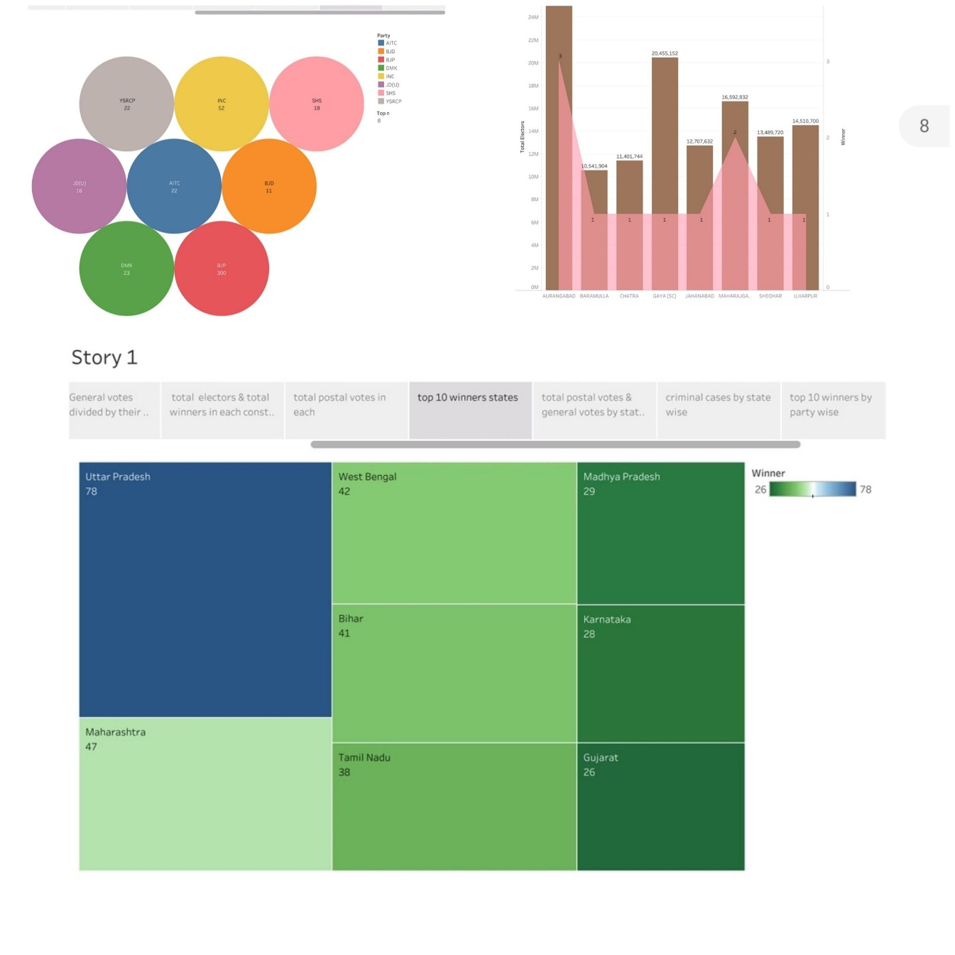The Bharatiya Janata Party received 37.36% of the vote, the highest vote share by a political party since the 1989 general election, and won 303 seats, further increasing its substantial majority. In addition, the BJP-led National Democratic Alliance (NDA) won 353 seats. .

# FUTURE SCOPE

Publishing helps us to track and monitor key performance metrics, to communicate results and progress. Help a publisher stay informed, make better decisions, and communicate their performance to others.

# APPENDIX

